# Welcome to your new tattoo!!!

## Self-expression

Tattoos are a way to show personality traits, tell a personal narrative, or simply show the world your sense of style. Using tattoos as a way to express oneself helps people improve their self-esteem and feel comfortable in their own skin.

**As an artist we are looking to find out exactly what you want to accomplish with your new tattoo! Meeting your needs and helping you find the ideal symbolism will allows us to take the next step in designing your custom art. We’ll also be able to go over with you the pain and application necessary to fulfill your desires towards body modification. Think before you ink!**

“I’m always willing to listen to someone’s ideas…because we can always learn more.” - Norman ‘sailor Jerry’ Collins

People get tattooed for many reasons, including: Artistic additions as paintings in their skin in a beautiful or moody way. As a spiritual connection toward beliefs systems and traditions. Memorials help people commemorate life-changing events and honor loved ones. Some even use tattoo as a means or rebellion to challenge social norms. Expressing their identity, bonding and connecting to family, pets and life partners. Covering up scars aids in confidence and creating irreversible visuals, empower an individual to not be afraid of what others think. Some even act on impulse and make decisions spontaneously marking a time in history, helping keep memories for the rest of your life.

## Mission statement

* This book is to inform the artist with essential information, targeting a streamlined process. Please use this distraction to ensure a comprehensive outline delivers all your expectations and goals.

|  |  |  |
| --- | --- | --- |
|  | Fill and/or Circle |  |
| Name: |  |  |
| Age: |  |  |
| Gender | Male | Female |
| Phone Number: |  |  |
| Where are you from? |  | Local to hawaii |
| Time you will be on island? |  |  |
| First tattoo? | No. | Yes. |
| Which artist would you like to execute your new tattoo? |  |  |

**Needs & Wants**

* (What)

What style is your new tattoo going to be?

**Japanese** (Distinct look and meaning always tells a story), **Black and Grey** (aka the OG style, shading and shadows), **Traditional** (old school with primary colors), **Neo-traditional** (finer lines, exaggerated features and a broad color palette), **Lettering** (calligraphic drawn letters or words, graffiti art) **Fine line** (aesthetically pleasing, hiding in the anatomy), **Tribal** (Polynesian, Native American, typically black work with elaborate patterns) **Water color** (abstract splashes with no outline) **Blackwork** (bold, solid and very noticeable) **Realistic** (photographic proportion simplified into a tattoo-able outline) **Realism** (Color or black and grey copies of a photo) **Portraits** (Color and black and grey photos of a face, or pet) **Hyper-realistic** (high definition exaggerated contrasts of real photos or subjects) **Geometric** (straight lines, dot work, crosshatching scared geometry and shapes) **Trash polka** (black and red abstract imagery) **Anime** *eastern or **Animation** *western (cartoon or comic book style that translates well into tattoo) **Small** (miniature images) **Abstract** (does not attempt to represent external reality, meant to differentiate) **3-D** (red and blue offset outlines) **Continuous line** (contours appearing to be unbroken) **Sketchy** (tailored to look like a pencil or brush, not clean and very authentic look) **Scary** or **Horror** (Dark arts, opposing aesthetic portraying triumph of pain or application. Requiring mental strength and endurance) **Invisible** (UV ink that only shows under a black light, also pale color that may be used as highlights) **Ignorant** (tattoos that push social boundaries, like the Aloha monkey)

* (Where)*See diagram on page 5

Where on your body do you visualize your tattoo? Are you looking for an eye-catching peace of art or is a more conspicuous location required. The latter being the more painful sections. The most resilient parts of the body to stretching are lower legs, upper chest, forearm and upper back region. The hip comes in as the top-rated location for women and the upper arm for men.

* (Why)

Why are you getting tattooed? A little back story behind the meaning of your tattoo can go a long way with an artist so they can make sure to capture any elements or details you wish to represent. Most common reasons are: Identity, Tattoos can create a new identity and show and easy way to share stories, make statements or show loyalty to a group. Literally wearing your heart on a ‘sleeve’ is one of the highest forms of self-expression. Commemoration is a way to bond with family, pets, life patterns, or to remember someone. In this way tattoos mask internal and external scars that can’t fully be treated. Same as the oldest tattoo in recorded history they are used for healing and can be used to reclaim your body after trauma or grief.

Some simply like the designs and beautiful artwork finding newfound confidence marking a fresh start again in life. Repeated exposure to tattoos can reduce stress and hormones in the body. Multiple tattoos have been found to reduce cortical levels and improve the immune system. Cortisol helps the body respond to stress appropriately aiding in your circadian rhythm.

* (When)

When do you want to get your tattoo? A lifelong commitment is essential to achieve your goals in tattoo. Carefully consider what you want before getting inked. If you’re having trouble deciding on a design or image, set it as the background on your phone. If you’re still attracted to the image, it will be a sign it may be suitable for a permanent tattoo. The best is being fully dedicated to the meaning and reason behind the tattoo. Secondly being prepared for the healing process and time to take care of yourself and the new tattoo. Keeping yourself calm and cool is the best to keep your tattoo healing more comfortable. Sweating can trap bacteria in a fresh tattoo, which can lead to infection. UV rays can permanently damage a tattoo and will instantly fell very uncomfortable. Sleeping can also be uncomfortable, and you never want to wrap you tattoo causing even more heat and sweat. Cooler temperatures mean easier healing. Give yourself time to recover especially with large pieces and heavily saturated work. Gently wash your tattoo with antibacterial soap and warm water. Pat dry with a clean towel. After a few days you can apply a thin layer of fragrance-free, hypoallergenic lotion to the dry tattoo. Applying too much Aquaphor or Bacitracin can also trap bacteria while moisturizer soaks into the skin. Protect your tattoo from the sun as it causes fading, avoid getting sweaty, submerging your tattoo in water and wearing tight clothing over it. Avoid touching your tattoo, as it flakes and peels avoid scratching and use the thin layer of moisturizer for relief.

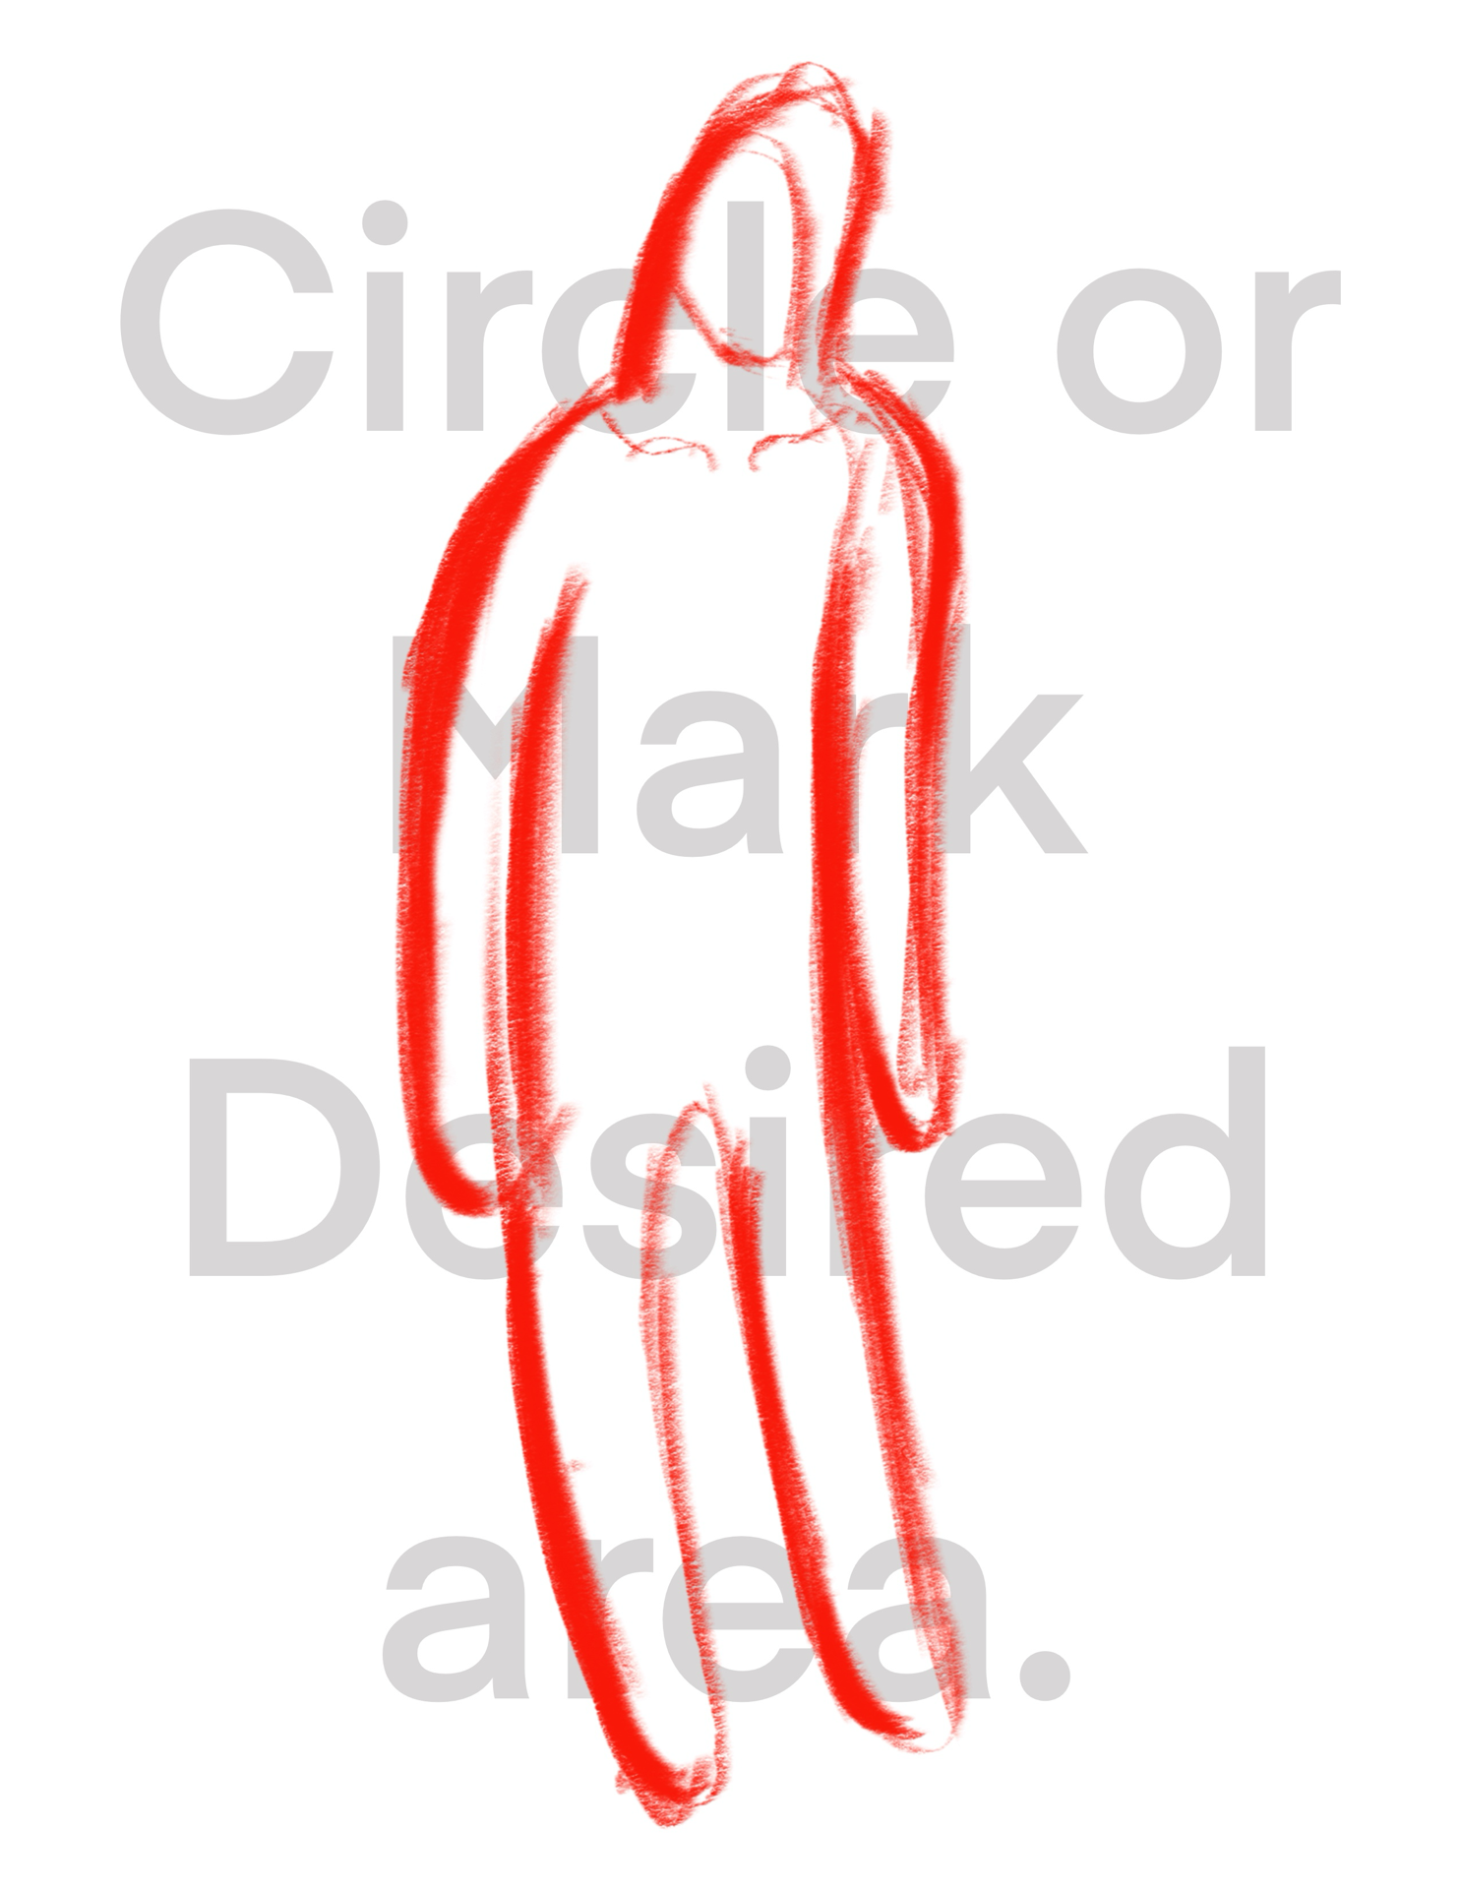.

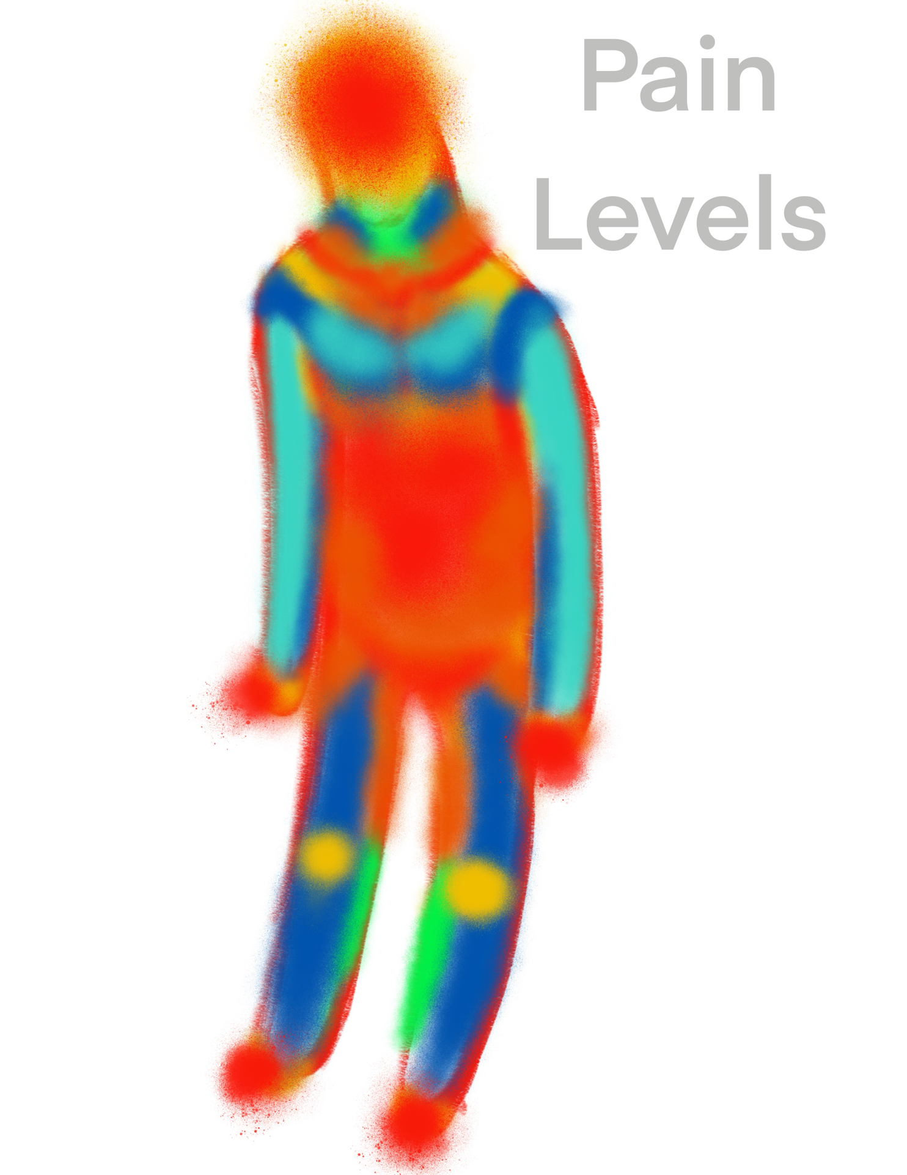

|  |  |  |
| --- | --- | --- |
|  | Cost/Pricing |  |
| What is your budget? |  |  |
| Looking for: | Flat rate | Hourly |
| Art deposit: |  |  |
| Ideal appointment day: |  |  |
| Design | Custom | Referenced |
| Art commission: |  |  |
| Additional information |  |  |

The average hourly rates generally fall between $150-$500, influenced by the artists skill level and the intricacy of the tattoo design. Artists typically charge a flat rate per piece on tattoos that will be completed in one session, while hourly rates are for large pieces over multiple sessions. Tattoo sessions can even range from $100,000+ by Ganga tattoo who even provide an anesthesiologist with multiple artists working on entire body suits. To world renowned Artists like Scott Campbell with a starting rate of $2000 for the first hour or @ishineink coming in around $350 an hour. If you are looking for the best deals finding an apprentice who is still learning the art or an Artist trying to expand their portfolio.

Pain Management

Yes, tattoo do hurt. This also depends on your desire to have the tattoo done! The procedure feels like scratching on a sunburn, as the needle gets closer to the bone you may also feel more vibration. The low pain level will increase into longer sessions as your natural endorphins wear off. After 4 hours this seems to most people’s threshold and client and artist may consider numbing medications if the tattoo must be completed in one day. The other way is to break up your large tattoo into multiple sessions starting with outlining, moving to shading or coloring and bolding lines the the following sessions.

The area may also feel sore or swollen for up to a week. Healing times can be more painful without adequate aftercare especially if the tattoo becomes infected or the wound re-opens. Location is a big factor on pain levels. For example, the head, face, armpit, ribcage, feet, groin, nipples and breasts are generally more more painful. While the outer forearm is considered one of the least painful areas.

Getting enough rest and drinking plenty of water before your appointment can minimize pain. Also having a full stomach before your session will keep your body more comfortable. Also, different techniques and styles of tattoo can help with pain levels, light fine line or black and grey will be less painful then solid filled traditional. Machine free tattooing can be less traumatizing to the skin. Choosing a reputable artist for the style of work you’re looking for in a licensed tattoo shop will help you stay relaxed and calm during the process.

Additional options available

Ask you artist for for any additional sketches or drawing from your tattoo.

Some may even be willing to create your tattoo as a finished piece of flash for your wall. Digital renderings and even painting of your custom art can be available at an additional cost.

This is interesting in the fact our human bodies are always growing and changing with age and exposure to the elements. Keep in mind your tattoo will change over the years and can always be retouched or recolored. Your art will never be able to be maintained like printed or painted art hanging on your wall indoors.

Please use the rest of the page to try and make a quick sketch of your design or scribble a basic one line design your artist can turn into something creative to match artist and client's imagination.